# 

Faculty of Engineering

Department of Electronic Engineering

Progress Report 3

|  |  |
| --- | --- |
| **Name** | Francois Mavunila |
| **Student Number** | N0172507W |
| **Project Title** | Taxi safety and robbery prevention system |
| **Supervisor** | Mr. B. Dlodlo |

# Introduction:

This Document gives details of the student’s work (progress) done on the project from the last progress report.

# Research on the fingerprint Sensor:

## Finger Print Sensor Literature:

Human fingerprints are widely used by law enforcement to match a suspect to a link for more than a 100 years now. They are used on our day to day activities to authenticate users when accessing their mobile phones, laptops and even access to building. Human fingerprints are detailed, unique, durable and difficult to alter hence they can be relied on for security measures.

### Characteristics Of fingerprints:

Fingerprints consists of friction ridges, which are raised lines and furrows, which are the valleys between those lines. The fingerprint ridge patterns are usually grouped into three types which have unique variations which include:

Loops:

Loops are prints that goes out and curves back to themselves to shape a loop. There are two types of loops which are

* Radial loops – which point towards the thumb or radius bone.
* Ulnar loops – which point towards the pinky or ulna bone.

The finger below shows the loops in a fingerprint.

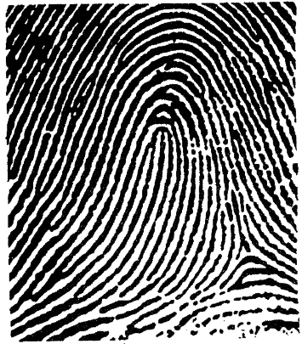

Figure 1: fingerprint loops

Source: Adapted from [1]

Whorls

Whorls are circular or spiral ridge lines and they are divided into four groups:

* Plain-which are concentric circles
* Central pocket loop-a loop with a whorl at the end
* Double loop- two loops that create an S like pattern
* Central pocket loop – a loop with a whorl at the end

The figure below shows the whorls in the fingerprint

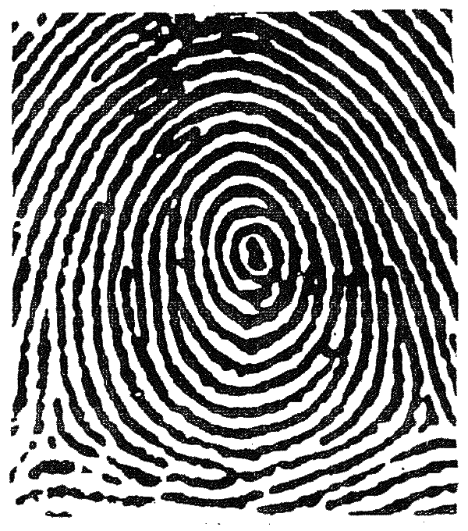

Figure 2-fingerprint whorls

Source: Adapted from [1]

Arches

Arches are a wave like pattern and are grouped into two categories which are tented arches and plain arches.

The figure below shows arches on fingerprints

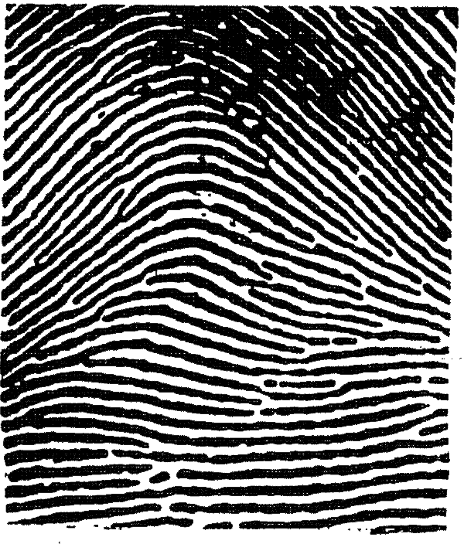

Figure 3: arches fingerprint

Source: Adapted from [1]

Loops makes about 60% of all fingerprint patterns, while whorls makes about 35% and arches about 5%.

## Types of Fingerprint sensors:

There are three main types of fingerprint sensors, which include:

Optical Scanners

Optical fingerprint sensors use a light emitting diode to illuminate the finger and an image of the ridges and valleys is taken and processed by the sensor.

Advantages of Optical Fingerprint sensors:

* Can be placed within capacitive displays and hence allows display fingerprint scanning.
* They are cheap to manufacture.

Disadvantages of Optical fingerprint sensors:

* + Can be easily spoofed
  + They are generally slower than other implementations of the sensor
  + They are bulky since they rely on led and a photosensitive element.

Capacitive Scanners

Capacitive scanners use electricity (uses a touch capacitive surface) to identify fingerprint patterns. When a finger is placed on the sensor, the capacitive surfaces measures the charge and generates an electric charge on places where the ridges are making contact with the surface and no electrical contact id determined in areas where there are valleys. The sensor uses this information to process a pattern of ridges and patterns.

Advantages

* They have high sensitivity
* They are faster than optical sensors

Disadvantages

* They cannot be placed on capacitive displays.

Ultrasonic Scanners

These scanners consist of an ultrasonic transmitter and receiver. An ultrasonic sound is sent to the finger and some of it is absorbed while some is reflected back depending on the ridges and valleys. The fingerprint processes the received signal and if enough signal is collected a 3D rendering of the surface can be created.

Advantages:

* Ultrasonic sensors can capture a highly detailed three-dimensional image
* They are more secure and more reliable than optical and capacitive sensors
* They can be used in in-display scanning.
* They can capture enough data even if the user has dirty hands.

Disadvantages:

* They are slower than capacitive sensors
* They are more expensive compared to the capacitive and ultrasonic sensors.

The AS608 Optical Fingerprint

## For the Project a AS608 Optical Fingerprint Sensor is used

The figure below shows the AS806 Fingerprint sensor. It main features include:

* Supply voltage: 3.3V
* Maximum current supply: 60mA
* Resolution: 500dpi
* Max fingerprint imaging time: 1s
* Storage: 162 templates
* Baud rate: 9600, 19200, 28800, 38400, 57600 (default is 57600)

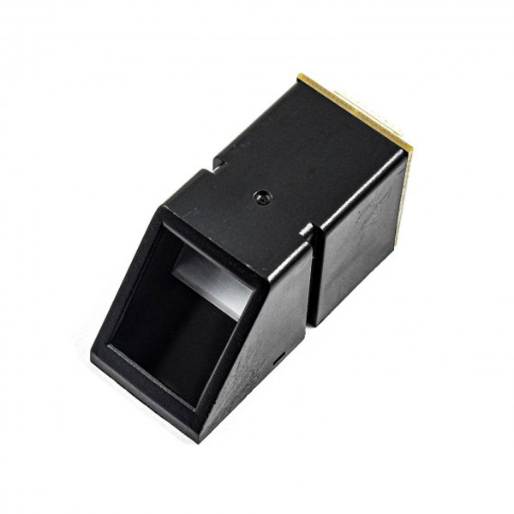

Figure 4: the AS608 Fingerprint sensor

Source: Adapted from [2]

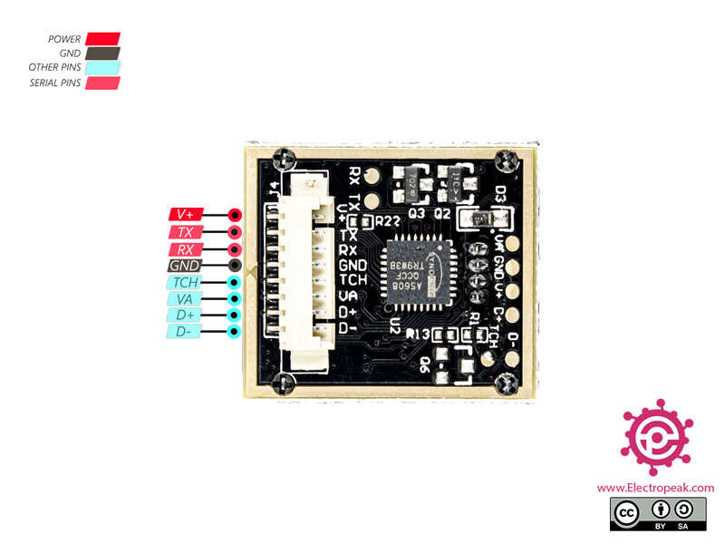

Figure 5: pin out diagram for the AS608 optical fingerprint sensor

Source: Adapted from [2]

The AS608 Fingerprint sensor has 4 useful pins as shown in the figure above:

* **V+**: Module power supply – 3.3V to 5V
* **TX**: Serial Transmitter
* **RX:**Serial Receiver
* **GND**: Ground

The working Principle of the fingerprint sensor:

The fingerprint module exposes two API processes which are:

* Fingerprint registration process

During the registration process two fingerprints are captured for the same fingerprint and the image is processed two times and generate a fingerprint template and store it in one of the 127 locations.

* Fingerprint matching process

The matching process is divided into 1:1 and 1:N processes. During the 1:1 matching process, the fingerprint is captured by the sensor and a template generated which will be compared to a specific template stored in the module, the process returns true for successful match and false for failed matching. During the 1:N the fingerprint is captured and a template generated that is used to search the whole database for the match will the closest score, success gives a return of true and failure is signalled by false. [3]

Reading the Fingerprint templates:

The sensor exposes another API used to read the fingerprint data from the registers and transfer them to the microcontroller via UART communication. The read data has 512bytes and below is the data from a thumb fingerprint formatted in hexadecimal form:



# Dealing with Objective Number 1- registration of the driver’s details including fingerprint data:

The student has managed to develop the skeleton of the registration of the driver subsystem, the figure below shows the general structure of the overall subsystem:

As shown above, the uses the HTTP protocol to communicate between the REST API server (nodejs server) and the React Single Page application and it uses the MQTT protocol to communicate between the microcontrollers, react app and the RESTAPI MQTT client interface.

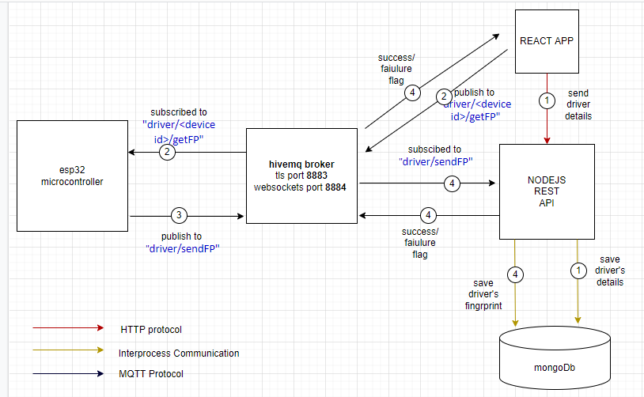

Figure 6:driver Registration process

During the registration process the following steps take place:

1. The Admin captures the driver’s information (name, national id, license number, number plates) and send them to the REST API via http and it is stored in the mongo Db.
2. If the details are captured correctly, the REST API send a 200 ok status to the React App and Upon reception the admin is taken to a page where he/she has to enter the driver’s national Id and device Id and publish them via a topic “driver/<device id>/getFP” with the message being the driver’s id.
3. The microcontroller is subscribed to the topic “driver/<its id>/getFP” and up reception of the message it prompts the driver to enter the fingerprint for scanning twice, generates a template and stores in address 101. It immediately runs a function to get the template and publish it via MQTT to the topic “device/sendFP” with a json information containing the device id, driver id and the fingerprint template in base64 format.
4. The RESTAPI MQTT client receives the json data, decodes it and updates the driver’s information with the fingerprint data and a success flag is sent to the react app.

# References

|  |  |
| --- | --- |
| [1] | " Writing and research," [Online]. Available: https://libguides.sait.ca/images/citing. |
| [2] | W. b. A. M. Shojaei, "Interfacing AS608 Optical Fingerprint Sensor Module with Arduino," [Online]. Available: https://electropeak.com/learn/interfacing-fpm10a-as608-optical-fingerprint-reader-sensor-module-with-arduino/. [Accessed 8th April 2022]. |
| [3] | R. E. (. p. ltd, "AS608 Fingerprint Reader Sensor Module With Cable," 2011. |